CLUE – Climate Literacy in Undergraduate Education
Data Analysis and Connecting Your Exposure to Microclimates and Climate Change

Last week, you collected 48 hours of temperature and humidity data that represents your personal exposure to varying thermal conditions. We have converted the humidity data into heat index for you already. Heat index is the combined effect of temperature and humidity, or the “feels like” temperature. During times of warm temperatures, high humidity can cause high heat indexes and cause you to have a harder time cooling yourself off and avoiding illness.
The objectives of this activity are to 1) graph and analyze the data you collected, 2) compare your data to others in your class, and 3) draw conclusions about causes of exposure and connections to microclimates and climate change. You have been provided a Microsoft Excel file with the classes’ iButton data on D2L. These data have been trimmed to only show temperature and heat index during the study period (Sunday, June 12, 12:01am through Friday, June 17, 11:59pm). If you know how to use Excel, you can create your own graphs that resemble those below. If you are unsure how to use Excel, we have provided instructions below on how to create graphs to analyze your data!
1. Graphing Your Exposure Data
Open the Excel file from the .zip file and find your exposure data. You will be able to find this using your student number. You will see many tabs on the bottom left corner:
- These tabs contain data from each person in your course. To navigate through additional tabs that are not shown, use the right and left arrows until you find your data.
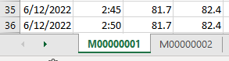

Navigate to your data tab, if you are not already there. In this tab, you will see several columns:
- Date
- Time
- Two columns relating to the iButton data you collected. These are listed as T, which is temperature in degrees Fahrenheit (°F), and HI, which is heat index in degrees Fahrenheit (°F).

You may have a column that has repeated pound signs (#), as you see below. This means your column is not wide enough to show the data.
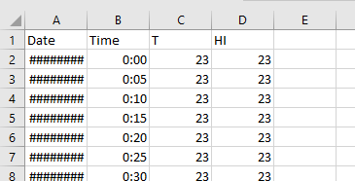
If this happens, double click the line to the right of the A (circled above) to auto-resize the column.
Graphing your temperature data
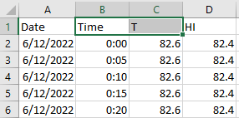
For your first graph, you are going to compare temperature in Fahrenheit “T (°F)” between yourself and others in the class.
- In your data tab, highlight cells B1 and C1.

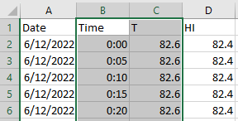
- Press the Control, Shift, and down arrow keys at the same time. This will automatically select all the data in these columns.

- In the ribbon/toolbar at the top of the screen, click “Insert.”
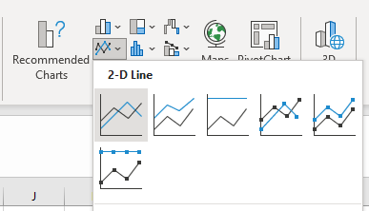
- Under “Charts,” click the down arrow next to the line graph. Choose whichever graph you like best under “2-D Line.”

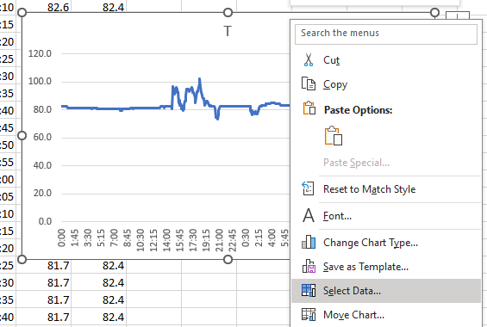
- Now you have a graph! Let’s add in your heat index data.
  - Right click anywhere inside the chart and click “Select Data.”
  - Under “Legend Entries (Series),” click “Add.”
  - Under “Series Name,” type “Heat Index” or “HI.”
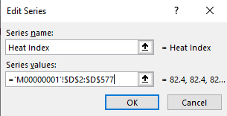
  - Click the up arrow next to the white box under “Series values.” Click on cell D2 and then hold down the Control, Shift, and down arrow keys at the same time to select all data in this column.
  - Click the down arrow to return to the previous window.
  - Click OK to close the “Edit Series” dialog box.
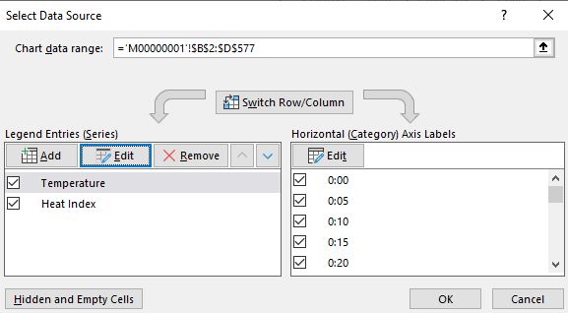
- Under “Legend Entries (Series)”, click on “T,” then click “Edit.”
  - Under “Series name,” rename this data series to something meaningful, such as, “Temperature.” Click OK.

- Click OK to close the dialog box.

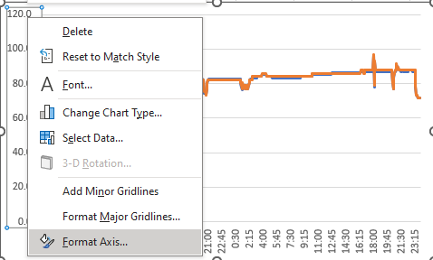
Let’s clean up your graph so it is easier to read
- On your graph, right click on the y-axis. Select “Format Axis.”

- You will want to set the minimum and maximum numbers on the y-axis to better fit the data, but this will vary based on the data you collected. As you look at the graph you created, determine the range of numbers would best fit the data you have graphed. For instance, in the example graphs above, the minimum of 60 and maximum of 110 were chosen as these numbers best encapsulated the data.
    - Your minimum: ___________
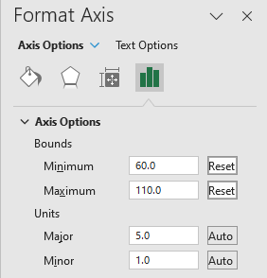
    - Your maximum: ___________

- In the Format Axis box under “Axis Options” and “Bounds,” set the minimum and maximum to the numbers you chose. These are the lower and upper temperatures that will show on your chart and will allow you to view the variations in your data more easily. Adjust these values until you are happy with your graph.
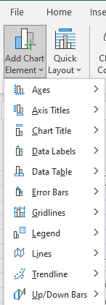
- Close the Format Axis box.
- Now, let’s add some labels to this chart.
- Click on your chart if it is not already selected.
- In the ribbon/toolbar at the top of the page, click “Chart Design.”
- Click “Add Chart Element” on the far-left side of this ribbon/toolbar.
- Click “Axis Titles” and then “Primary Horizontal.” Double click the x-axis title that appears in your graph and rename this something reasonable, such as “Time.” You’ll notice that this axis starts at the beginning of your data collection period and runs through the end of the collection period.
    - Complete the same procedure to add the axis title for “Primary Vertical,” or your y-axis, and label this “Temperature and Heat Index (°F).”
Tip: To add the degree sign in your axis title, hold the ALT key down and then type 0176. Release the ALT key and the degree sign will appear.
- In “Add Chart Elements,” click “Legend” and select where you’d like your legend to be placed.
- In “Add Chart Elements,” click “Chart title” and select where you’d like this to be placed. Rename your graph.
- Resize your chart as needed. Making your graph wider will make it easier to read.
- Your resulting graph should look like this, though your data may show different patterns:
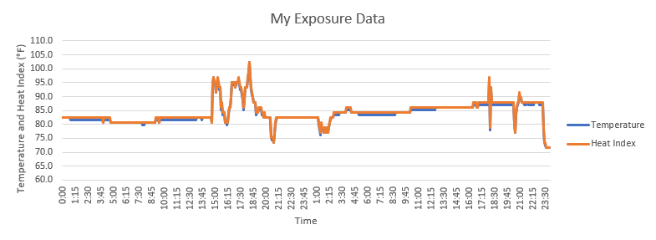
Copy and paste your graph below.

Use your graph to answer the following questions.
  - What patterns do you see in your exposure data? Specifically, what times were you exposed to higher or lower thermal conditions?

  - Thinking back to when you collected data, what were you generally doing during times of higher and lower thermal exposure (e.g., working, sleeping, in class)?

  - Do you see differences between temperature and heat index? If so, why do you think those differences exist? Note: if data were collected during cooler weather, there may be little to no difference between temperature and heat index.

  - We have discussed the various factors that can affect microclimates throughout rural and urban areas. These include albedo, energy trapping, air mixing, landcover (shading and evaporative cooling), anthropogenic heat, and air pollution. How has each of these affected your thermal exposure? Be specific in your explanations and be sure to touch on all factors listed above.

  - Consider the different social factors that can affect your vulnerability to thermal exposure, which can include age, social support, medical, income, education, and/or others. Knowing your personal exposure, which social factors might cause you to be more or less vulnerable to health conditions related to the thermal conditions you are exposed to. Be specific and thorough in your explanations.

2. Comparing Exposure Data with Classmates
Now, let’s add the temperature data from other students in the class to see how your exposure compares to theirs.
- Right click in the graph area and select “Select Data.”
- Under “Legend Entries (Series)”:
  - Uncheck the box next to your heat index data set. This will remove your heat index data from the graph as you will not be using it further.
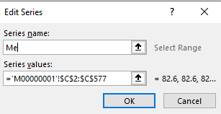
  - Click on your temperature data set and then “Edit.”
  - Under “Series name,” type your name or another nickname for yourself. This will help to identify your data as compared to other data sets. Click OK.
- Under “Legend Entries (Series),” click “Add.”
- In the box under “Series name,” type “Classmate 2” or a similar nickname so you can distinguish between the data sets.
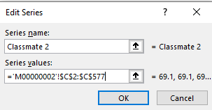
- Click the up arrow next to the white box under “Series values.” Navigate to another classmate’s tab. You can choose a data tab at random. Click on cell C2 and then hold down the Control, Shift, and Down arrow keys at the same time to select all data in this column.
- Click the down arrow to return to the previous window.
- It should look like this (your numbers will be different).
- Click “OK.” You will see a new line added to your chart.

- Repeat this procedure to add at least three more sets of your classmates’ data. You should have five total sets of data on your graph, including your own.
- Click “OK” in the “Select Data Source” box.
- You now have the temperature exposure data from you and four other classmates graphed!
- If needed, adjust the y-axis minimum and maximum range bounds under the “Format Axis” box.
- Rename your graph to something like “Exposure Data.”
- Rename your y-axis label to “Temperature (°F).”
- Your graph should look something like this:
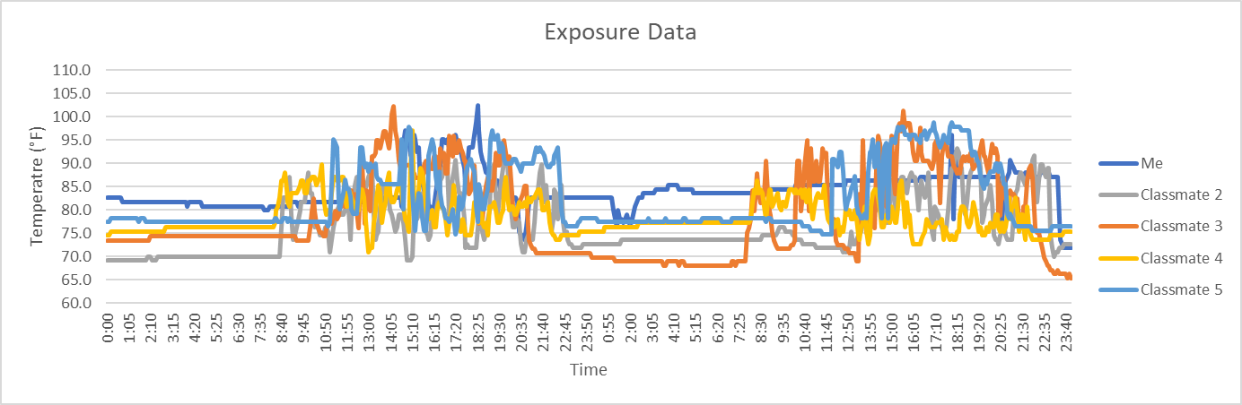
Copy and paste your graph here:

Use your graph to answer the following questions.
- How does your thermal exposure compare to others in the class? Be specific in comparing both the timing and degree of exposure.

- Considering the idea of microclimates and the lifestyles of college students, why might these differences exist?

3. Comparing Social Factors with Your Classmates
Now that you have compared exposure data, let’s look more deeply at the following social factors: employment, housing type, and physical environment around housing.
- Right click in your graph and click on “Select Data.”
- Under “Legend Entries (Series),” uncheck all data sets except for your own exposure data.
- You will now add data that represents social factors. In the tabs at the bottom of the excel file, you will see tabs named “Employment,” “Housing Type,” and “Physical Surroundings.” In these tabs, the exposure data has been sorted and averaged based on the answers provided on the iButton log and survey sheet.
  - To add housing type data to your graph, click “Add” under “Legend Entries (Series).”
    - Under “Series values,” click the up arrow and navigate to the “Housing Type” tab.
    - Determine the data you want to graph. Here, you are provided with options of urban, suburban, and rural. Choose a set of data that differs from your own. For instance, if you live in an urban area, graph either the rural or suburban data.
    - Click on the cell below the title of the data you would like to graph and then Shift+Control+Down arrow to select the data in the column. Click OK.
    - Provide a name for the new series that explains the data (e.g., suburban, rural).
  - Repeat this process to add a new line for employment and physical surroundings using data that differs from your employment and physical surroundings, respectively.
  - You should have a graph that results in four data lines: Your exposure data and one housing type, one employment type, and one physical surrounding type that differs from your own.
  - Rename your graph.

Copy and paste your graph here:

Use your graph and knowledge of microclimates, climate, and climate change to answer the questions below.
- Compare and contrast your exposure and social factors to those that you graphed. Be descriptive in your response and provide information on why these differences exist.
Housing Type:

Employment:

Physical Surroundings:

- Consider the differences in exposure between the three physical surroundings options (urban, suburban, rural). Who would you expect to be most exposed to extreme thermal conditions:
    - during a heat wave?

    - with increased temperatures associated with global warming?

- Provide and explain at least three ways that could assist in decreasing thermal exposure vulnerability and risk as global temperatures continue to rise. These can relate to the physical environment, policy, housing types, transportation, economics, and so on.

- Our Earth has already warmed about 2°F since the Industrial Revolution and is expected to warm another 7.2°F by 2100 if global emissions continue on the same trajectory as they are on today. Consider your current thermal exposure and how increased warming will have an effect on your future. How might you reduce your exposure and lessen the possibility of thermal-related illness? Specifically:
    - What would be your ideal housing type to reduce your exposure? Explain.

    - What would be your ideal physical surroundings to reduce your thermal exposure? Explain.

    - As we know, life can throw some curve balls. If you are not able to experience your ideal conditions, how could you reduce your exposure using everyday decisions in your life. These decisions could include the time of day you spend outside, changing your physical environment, changing transportation options, changing the type of work you do, etc.

    - Suppose you work at a job in which you are potentially exposed to extreme heat and humidity, and changing jobs is not an option right now. What could you do to reduce your risk?

